**Project Design Phase-II**

**Data Flow Diagram & User Stories**

|  |  |
| --- | --- |
| Date | 09 November 2022 |
| Team ID | PNT2022TMID36774 |
| Project Name | Smart Solutions For Railways |
| Maximum Marks | 4 Marks |

**Data Flow Diagrams:**

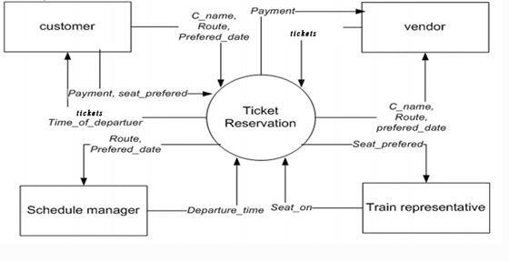

**User Stories**

Use the below template to list all the user stories for the product.

|  |  |  |  |  |  |  |
| --- | --- | --- | --- | --- | --- | --- |
| **User Type** | **Functional**  **Requirement**  **(Epic)** | **User Story Number** | **User Story / Task** | **Acceptance criteria** | **Priority** | **Release** |
| Passenger | Online  Registration | USN-1 | As a passenger, I can register for the application by entering my email, password, and confirming my password and to create a login credentials so I can securely access myself service online account. | I can access my account  /Input data fields to enter:  1.Username/email  2.Password | High | Sprint-1 |
| Passenger | Ticket  Conformation | USN-2 | As a passenger, I will receive confirmation email once I have registered for the application to check my ticket whether it is conformed or not. | I can receive confirmation email & click confirm | Medium | Sprint-1 |
| Passenger | Payment | USN-3 | As a passenger, I can register for the application through Facebook and want to pay my ticket cost in online payment. | I can register & access the dashboard with Facebook  Login | High | Sprint-2 |
| Passenger | Booking status | USN-4 | As a passenger , I can register for the application through Gmail | E-Ticket | High | Sprint-3 |
| Administrator | Login and update information. | USN-5 | As a admin , I can log into the application by entering email & password ,and to check the trains details | Train Details | High | Sprint-1 |
| **User Type** | **Functional**  **Requirement**  **(Epic)** | **User Story Number** | **User Story / Task** | **Acceptance criteria** | **Priority** | **Release** |
| Ticket Collector | Dashboard | USN-6 | As a Ticket Collector ,I want to check the users whether  he/she have tickets or not with scanning the  QR Code | QR CODE | High | Sprint-4 |
| Passenger | Knowing Current  Location details | USN-7 | As a Passenger,I want to know the train current location. | GPS of train | Medium | Sprint-4 |